USER MANUAL FOR
BILL TRACKING SYSTEM



Contents
1. Introduction 3
1.1 Purpose: 3
1.2 Overview 3
1.3 Intended Audience 3
1.4 Document Conventions 3
1.5 References 3
2. Process’ Listings and Definition 4
3. Login and Bill Tracking 4
Step 1: Where and How users can Login? 4
Step 2: What processes and information a user can access? 5
4. Dashboard 6
5. Central DAK Process 6
Step 1: What is Central DAK and its purpose? 6
Step 2: How to Add a Central DAK? 6
6. Bill Receipt Generation 8
Step 1: How to create the Bill Receipts 8
7. Bill Movement 10
8. Purchase Order (PO) Process 14
Step 1: How to view PO List and Add PO? 14
9. Settings 16
Step 1: How to add different users (Vendor, User, and Department)? 16
10. Reports 21
Step 1: How to view Reports? 21
11. Vendor Login 24
Step 1: Where and How users can Login? 24
Step 2: What processes and information a user can access? 25
Step 3: How to submit a new Bill? 26
12. Payment Status 27
Step 1: How users can check the payment status? 27

- Introduction
  - Purpose:
This user manual comprises of a detailed description, capabilities, and step-by-step procedures for Users (FCI’s Department Users, FCI’s Employees and Vendors) to efficiently use the ‘Application Bill Tracking System’.
  - Overview
The details mentioned within this document may be modified, and additional information may be added as per the inputs, suggestions, and feedbacks of different stakeholders.
  - Intended Audience
The intended readers of this document are FCI’s Officials who will be using ‘Application Bill Tracking System’ for different processes.
  - Document Conventions
This document uses the following conventions:
Content | Font | Line Spacing
Header | Arial – 16 – Bold | 1.5
Sub – Header | Cambria – 14 – Bold | 1.5
Sub-Sub Header | Cambria – 13 – Bold | 1.5
Text | Cambria – 11 – Regular | 1.5
  - References
- UAT Observations
- Inputs, feedbacks and suggestions received from the development team.

- Process’ Listings and Definition
There are following different processes in the ‘Application Bill Tracking System’:
- Central DAK Process
- Bill Receipt Generation Process
- Bill Movement Process
- Purchase Order Process
- Vendor Login
- Payment Process through Account Payable Module.
- Login and Bill Tracking

Step 1: Where and How users can Login?
FCI’s Admin and other users like third party vendors will be able to login through following URL and is compatible with Google Chrome:
https://fcilekha.in:7778/billtracker/ on clicking the below screen will appear:
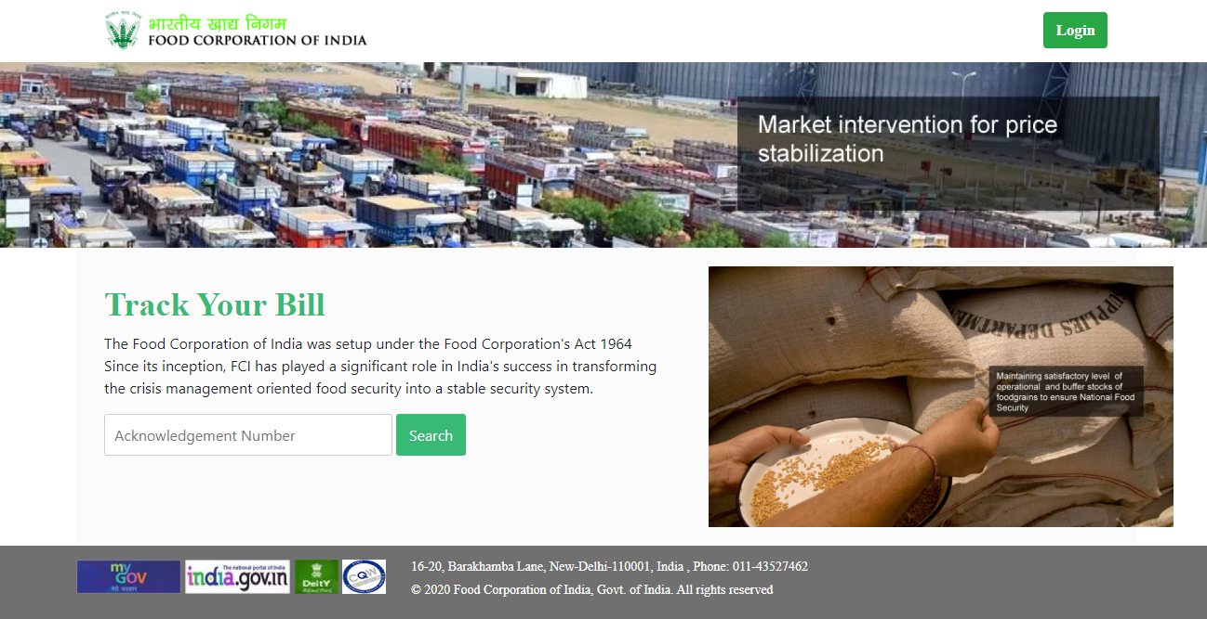
On clicking the Login Button, users will be redirected to the Login Page.

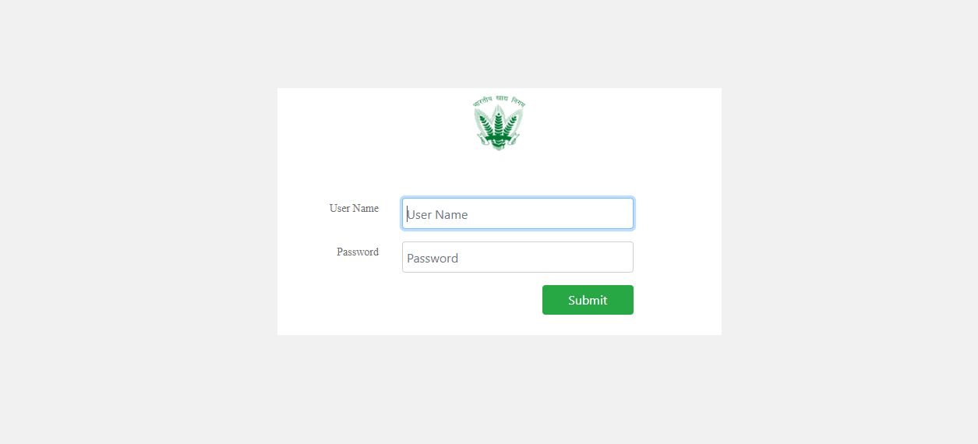
Users will need to enter valid credentials in order to successfully Login. After entering the user name and password and submitting, the users will Log in to the Application Bill Tracking System.

Step 2: What processes and information a user can access?
After successful login, the user will be redirected to the Application Bill Tracking System’s screen to access different processes. Username and Unit Code of the logged-in user will be displayed and here different sections as per user rights assigned to particular users are displayed as Tabs such as Dashboard, Central DAK, Generate Bill, Bill Movement, PO, Settings, Reports and User Profile with an option to navigate to different sections on clicking.
By default, Dashboard page will be displayed containing the details of a particular bill such as Acknowledgement No., Vendor Name, Bill No., Bill Amount, Bill Date, Department and Action etc.
See the below image for reference:
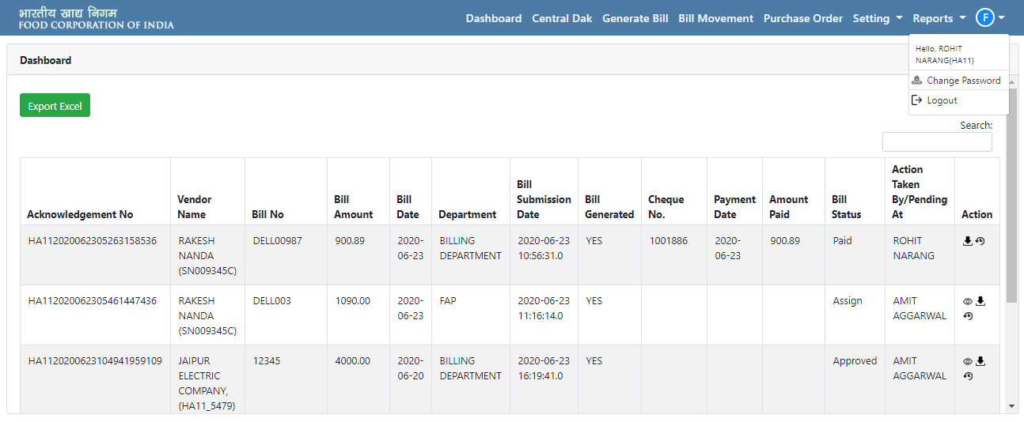

- Dashboard
After successful Login, the users will be redirected to their Dashboard section. Here the details of the various bills and central DAK data will be displayed. The users will also be able to view the details and download the files attached to the particular bill by clicking on the relevant button under the action section.
Search: The user will be able to search the details by providing the Search Keyword in the search box.
Export Excel: On clicking, the displayed data on the Dashboard will be downloaded in an MS Excel.
Refer the below image for reference:
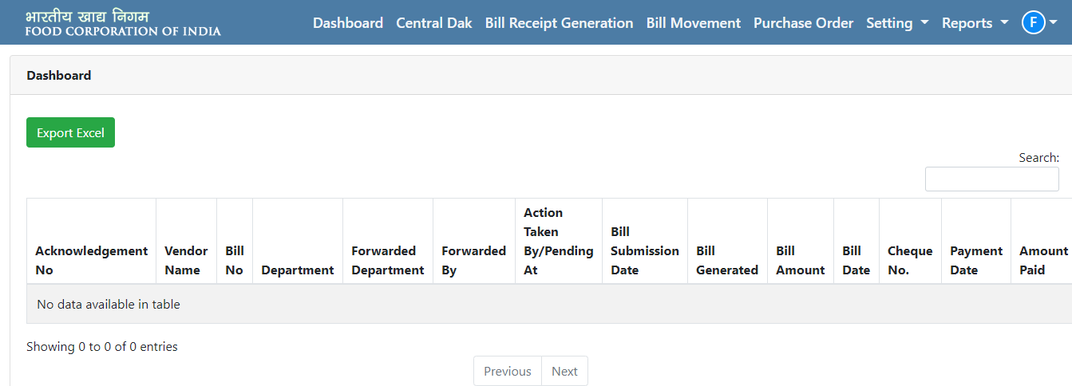

- Central DAK Process

Step 1: What is Central DAK and its purpose?
The first step in the BTS cycle will be to accept all the physical third-party bills by making an entry in the central DAK “add” tab. The entry in central DAK will be done by the person who has been assigned the responsibility of Central DAK at particular Unit office. The basic purpose of central DAK will be to accept all the third-party bill and provide an acknowledgement number through BTS system.
After creation of Central DAK, an Acknowledgement No. is generated so that the bill can be tracked, and payment can be made to vendor after departmental approvals and clearances.

Step 2: How to Add a Central DAK?
The user will be redirected to the Central DAK page on clicking the Central DAK tab displayed on top of the page. The users can add a Central DAK by clicking on the Add Central DAK Button available on the top-right section of the page.
Note: The Central DAK can only be edited by the user who has created it or Manager/ Department Head/ Super Admin and an error pop-up message will be displayed in case any other user tries to create the Central DAK. The user will be able to search the details by providing the Search Keyword (including Acknowledgement Number) in the search box of central DAK.

Refer the below images for the same:

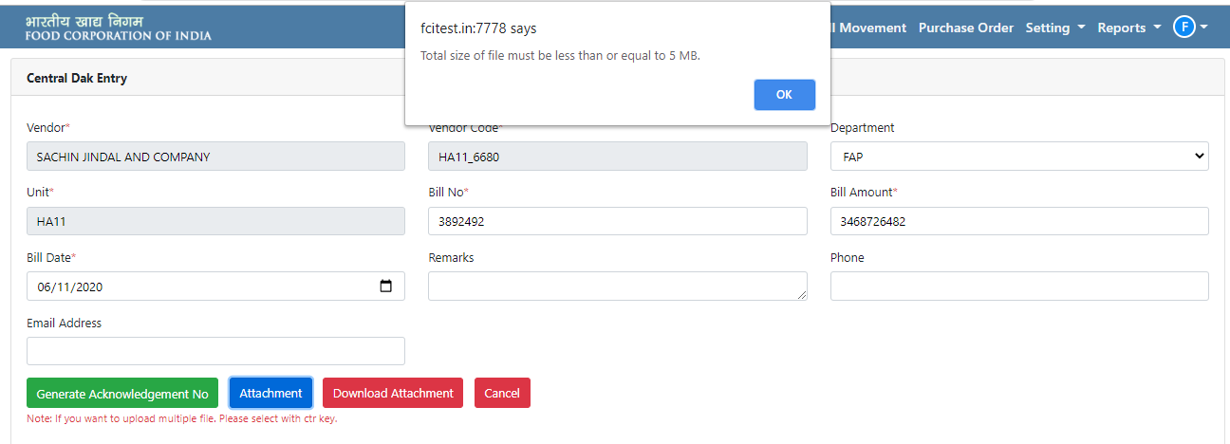
The users will need to provide following details in order to add a Central DAK:
- Vendor Name (mandatory)
- Vendor Code (mandatory)
- Select Department (Dropdown) (mandatory)
- Unit (mandatory)
- Bill No. (mandatory)
- Bill Amount (mandatory)
- Bill Date (Calendar) (mandatory)
- Phone Number (Optional)
- Email Id (Optional)
- Remarks (Optional)
Following buttons will be available to the users:
Generate Acknowledgement No.- On clicking, a unique Acknowledgement No. will be generated. On successful generation a notification will be displayed on the page.
Attachment: The users will be able to attach multiple files by clicking on this button. (Max. file size of total attachment as 5 MB is allowed otherwise an error message will be displayed)
Download Attachment: The attached files can be downloaded through this button.
Cancel: On clicking, the Central DAK page will be closed.
Refer the below images for reference:

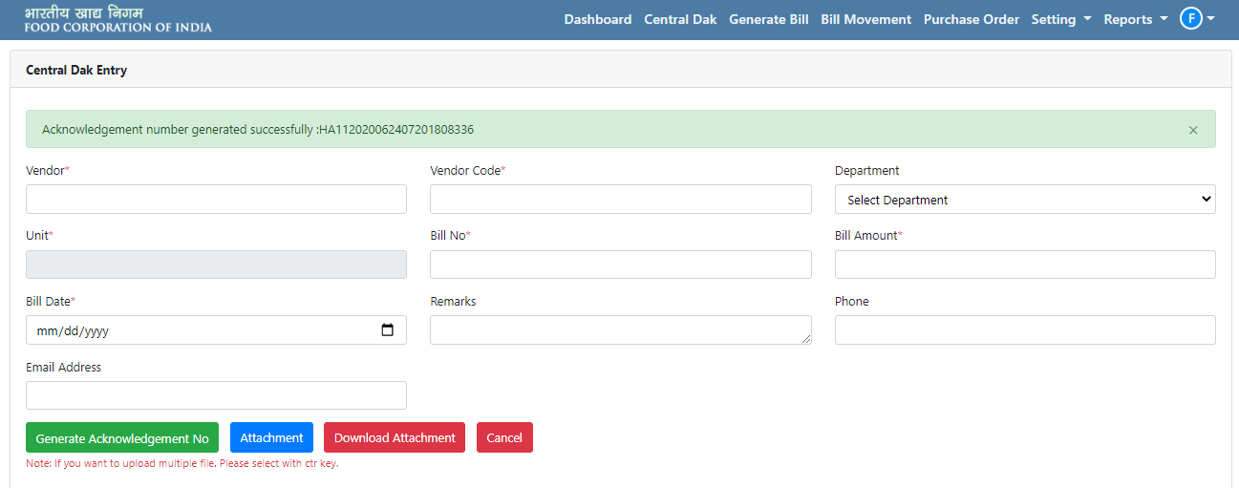
The Department Head and Manager will be able to process the Bills and they can assign the bill to any user within the same or other department.
Note: The Central DAK can be added by Admin, Users and Manager.
- Bill Receipt Generation

Step 1: How to create the Bill Receipts
On clicking bill generation option, all the details of the previously added Central DAK will be visible and the department head/Manager will be able to assign to a particular user by clicking on the edit button present in the actions section. There are two ways of bill generation in the system depending upon the Bill Type i.e. With PO and Without PO. In case of with PO the Admin/User/Manager will have to create a Purchase Order (PO) for the Vendor before proceeding with the bill generation and the PO No. field will get enable and the PO No. will be auto-populated based on the vendor details.
Refer below images for better understanding:
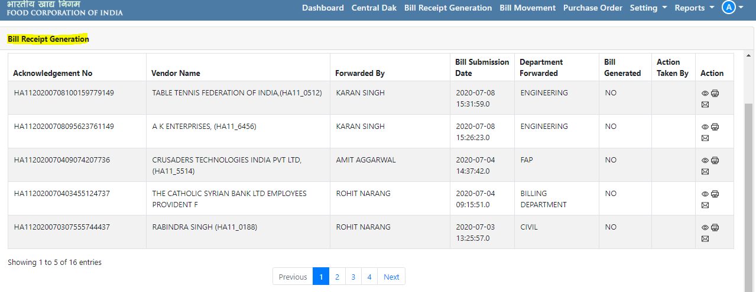
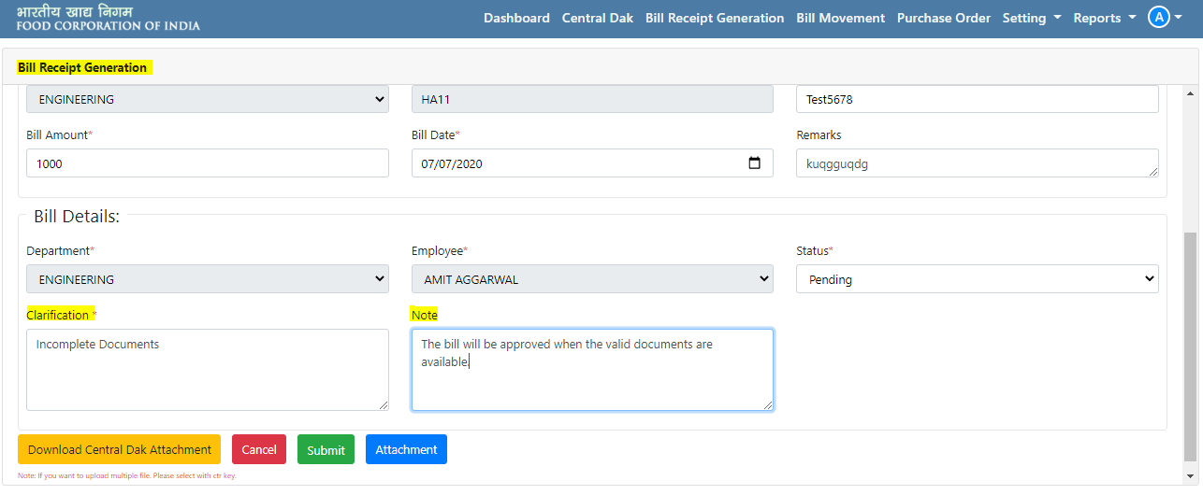
The users will need to provide following details in order to add a Central DAK:
- Bill Type (Dropdown) (With PO and Without PO)
- PO Number (in case of with PO)
Note: The users will be able to edit and update the fields like Bill Number, Bill Amount and Bill date if required.
The department head/ Manager will be able to generate the Bill auto assigned by central DAK for their department.
- Bill Movement
After the bill is generated, the concerned department can take following actions on the bill assigned to them –
The users will be able to approve/assign the bill by clicking on the Edit Button present in the actions section.
- Assign: On clicking, the bill will be assigned to the selected user in the department.
- Reject: On clicking, the bill will be rejected.
- Pending: On clicking, the bill will be put on Hold until the clarification is provided on the bill.
- Approve & Assign: On clicking, the bill will be approved and will be initiated for payment.
  - Assign Department
  - Assign Employee
If the Bill is assigned to the particular User, then he can go to bill movement tab for taking further necessary action on assigned bills.
Note: Share to ERP Button will be displayed in case the bill is Approved and assigned to the user of Billing Department.
Following Buttons will be available to the users:
Download Central DAK Attachment: On clicking, the attached files will be downloaded in a zipped format.
Attachment: The users will be able to attach multiple files by clicking on this button.
Submit: On clicking the bill will be submitted as per the status selected by the user.
Cancel: On clicking, the Central DAK page will be closed.
Note: The bill generated status will be changed to Yes after successful submission of the bill. No changes can be made once a bill has been generated by the department head.
Refer below images for better understanding:
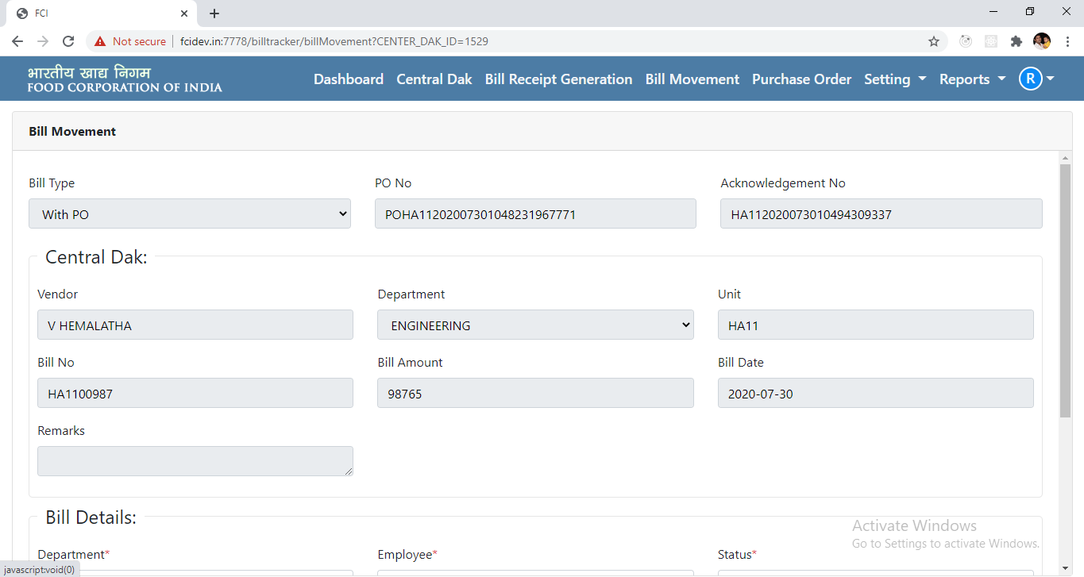

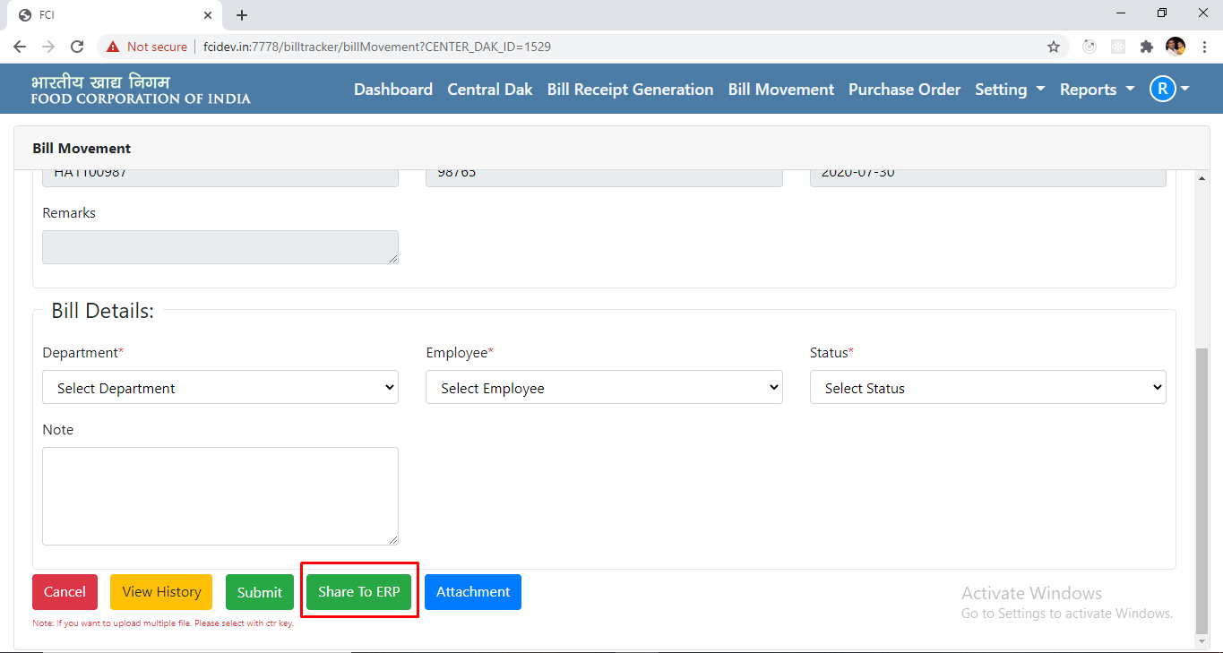

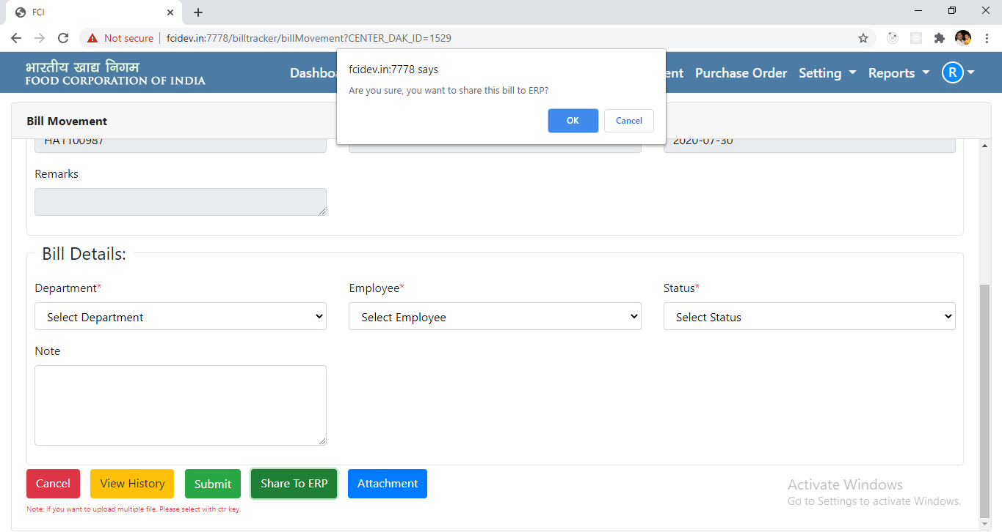

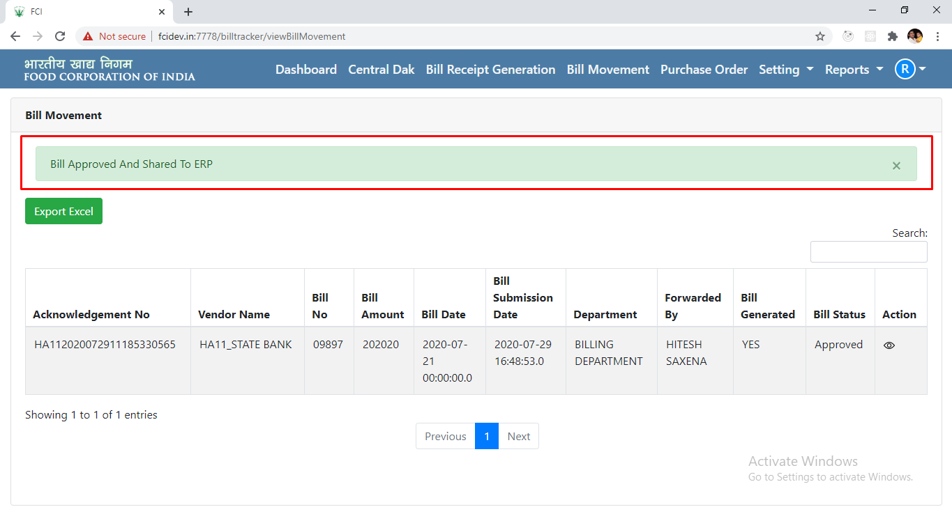

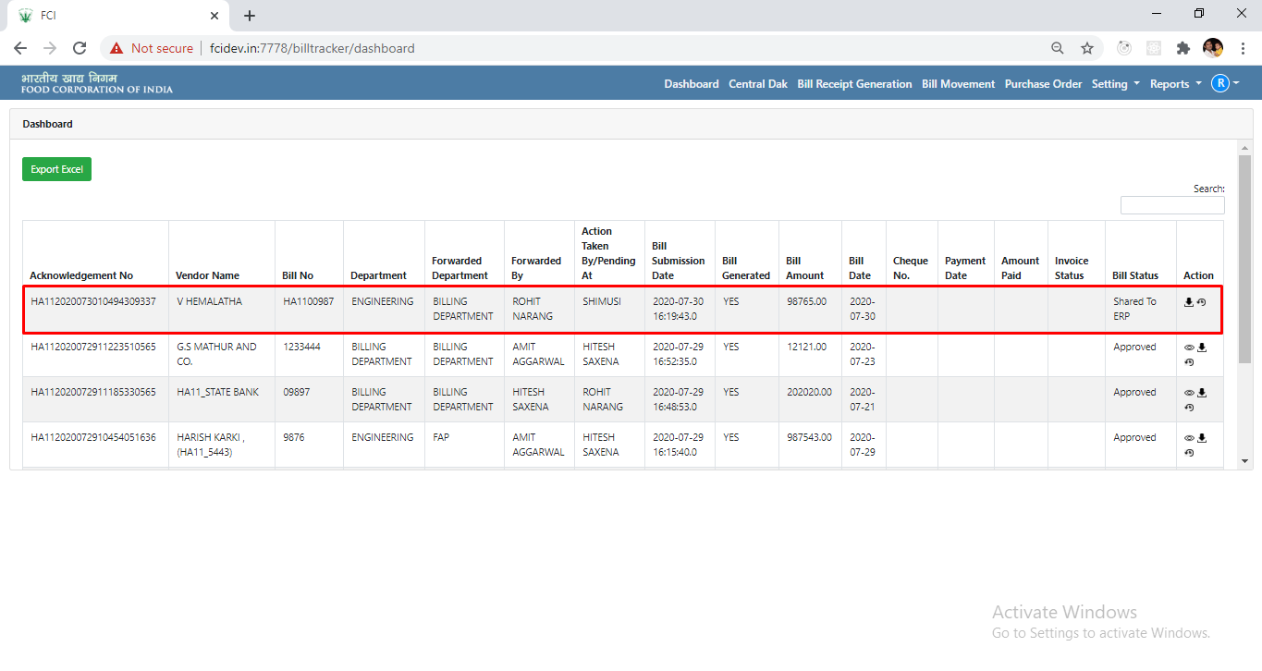
View History: On clicking, the History related to the bill will be displayed.
See the below image for reference:
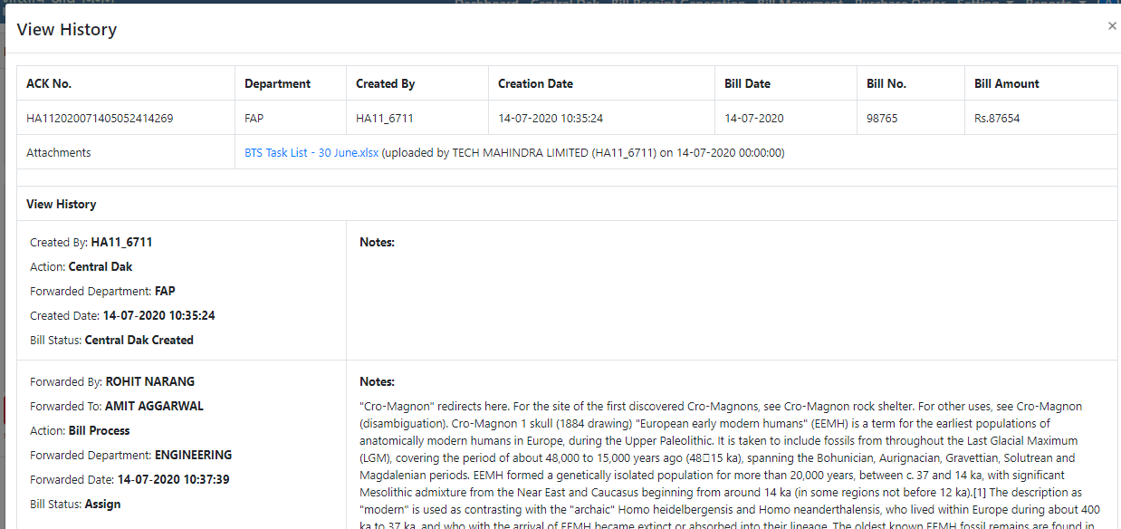

- Purchase Order (PO) Process

Step 1: How to view PO List and Add PO?
Purpose of PO form is to enter the detail of all the work orders issues by particular department. After Login, the users having PO access will have to click on the PO Tab in order to view the PO List and Add a PO. On clicking the PO Tab, all the Purchase Orders will be displayed along with the following details:
- PO No.
- Vendor Name
- Creation Date
- Type
- Created By
- Total Amount
- Action
Search: The user will be able to search the details by providing the Search Keyword in the search box.
Action: On clicking the Edit Button, all the details related to the particular PO will be displayed and the user can edit the following details:
Header Level Fields
- PO Type* (Dropdown) (Standard PO, Blanket PO)
- Vendor Name*
- Vendor Code*
- Vendor Site*
- PO Creation Date*
- Need By/Delivery Date *
- Ship To*
- Bill To*
- PO Status* (Dropdown) (Approved, In process, Incomplete, and Cancelled)
- PO Approval Date*
- Business Unit*
- Currency*
- Total Amount*
- Remarks
- Payment Term
Line Level Fields
- Serial Number*
- Item Name*
- Description*
- Quantity*
- Rate*
- Total*
Decision Buttons Available:
Save: On clicking, the updated PO Details will be saved.
Attachment: On clicking, the user will be able to attach multiple documents.
Download Attachment: On clicking, the user can download the attachments in the Zipped Format.
Cancel: On clicking, the PO Edit page will be closed.
Refer the below images for reference:
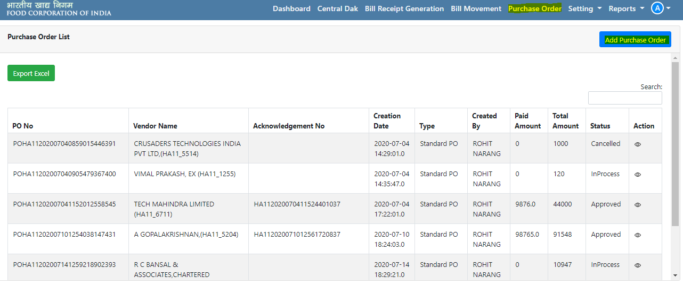
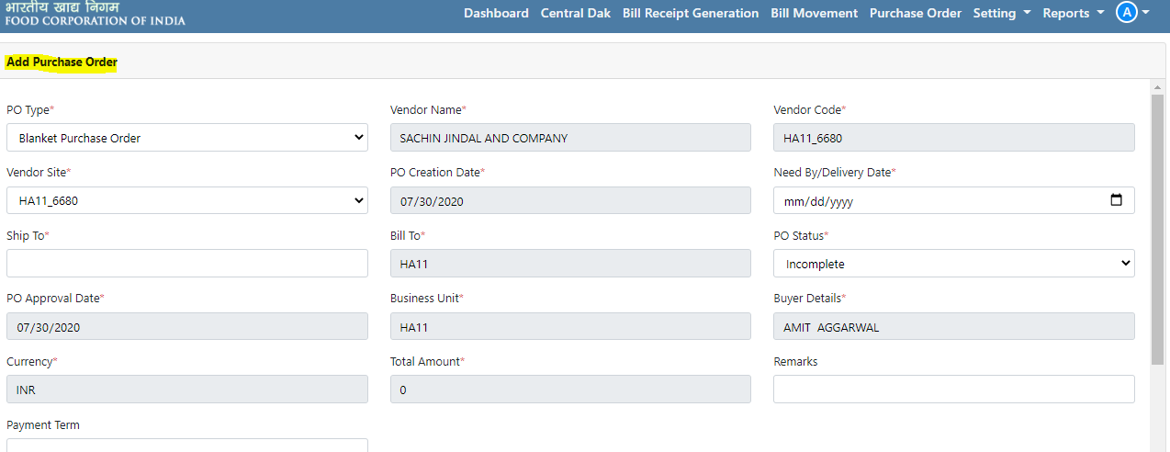
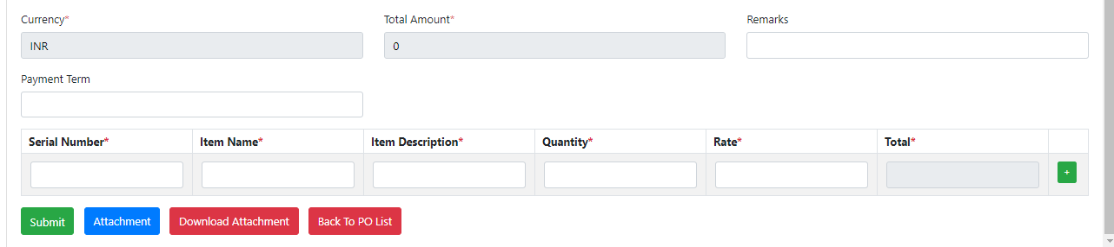

- Settings

Step 1: How to add different users (Vendor, User, and Department)?
There are three types of sections here namely Vendors, Users and Department and on clicking respective section, a page will appear showing the respective list of added users/Vendors/Departments. The admin can Edit the details and also Reset the password of different users.
Refer the below image:
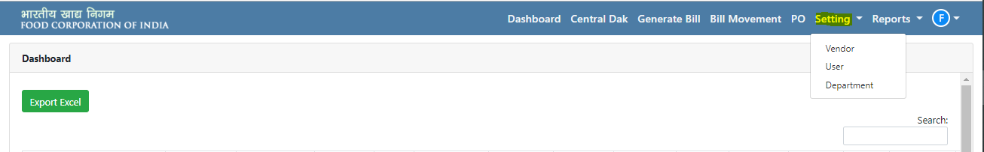
Adding Vendors:
On clicking Vendor, the added vendor list will be displayed along with the option to Add Vendors by providing the following details:
- Vendor Name
- User Name/Vendor Code
- Unit
- Email
- Phone Number
- Status (Dropdown) (Active, In-Active)
- Department (Multiple Select using ctrl option) (CIVIL, FAP)
- Save (Button)
- Cancel (Button)
On clicking Save Button, the vendor details will be added and saved in the system.
Refer the people images for reference:
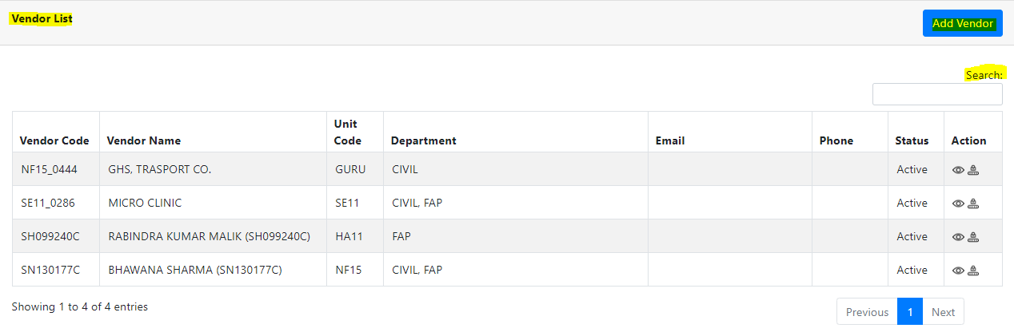
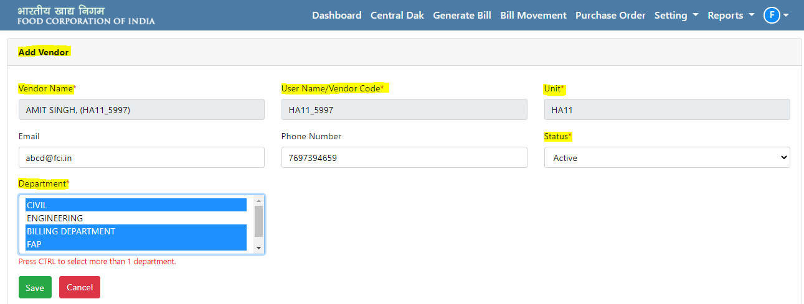
Adding Users:
The admin/Nodal Officer of a particular Unit will be able to Edit the details of different added users and can also Reset the password of different users.
On clicking User, the added user list will be displayed along with the option to Add User by providing the following details:
- Employee Name
- User Name/CPF#
- User Type (Dropdown) (User, Department Head, and Manager)
- Unit
- Email
- Phone Number
- Status (Dropdown) (Active, In-Active)
- Department (Multiple Select using ctrl option) (CIVIL, FAP)
- User Permission
- Central DAK
- Generate Bill
- Bill Movement
- Setting
- User (option available to admin and Nodal officer)
- Vendor
- Department (option is available only in Admin’s Account)
- PO
- Reports
- Save (Button)
- Cancel (Button)
On clicking Save Button, the user details will be added and saved in the system.
Note:
- Admin can assign different permissions to user as per the roles and designation.
- In a single unit, Department Head can be assigned single or multiple departments.
- One department can’t have multiple department heads for the same unit.
- Managers/Department Head/ Users will be defined unit-wise and they will have access to their central DAK units only.
- System will allow an employee to be created only once in the system and an error message will be displayed in case the user already exists in the system.
- If user is Inactive in any Unit, then the same user can be added in another unit.
Refer the people images for reference:
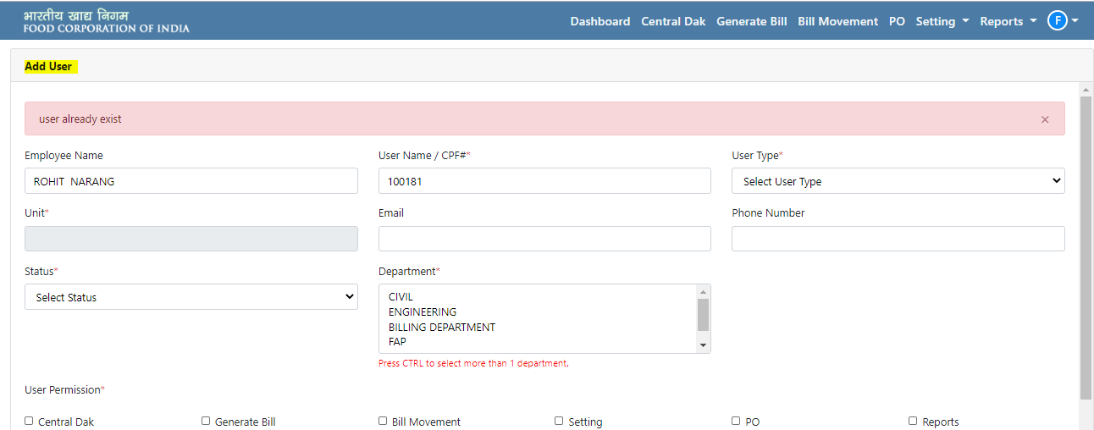

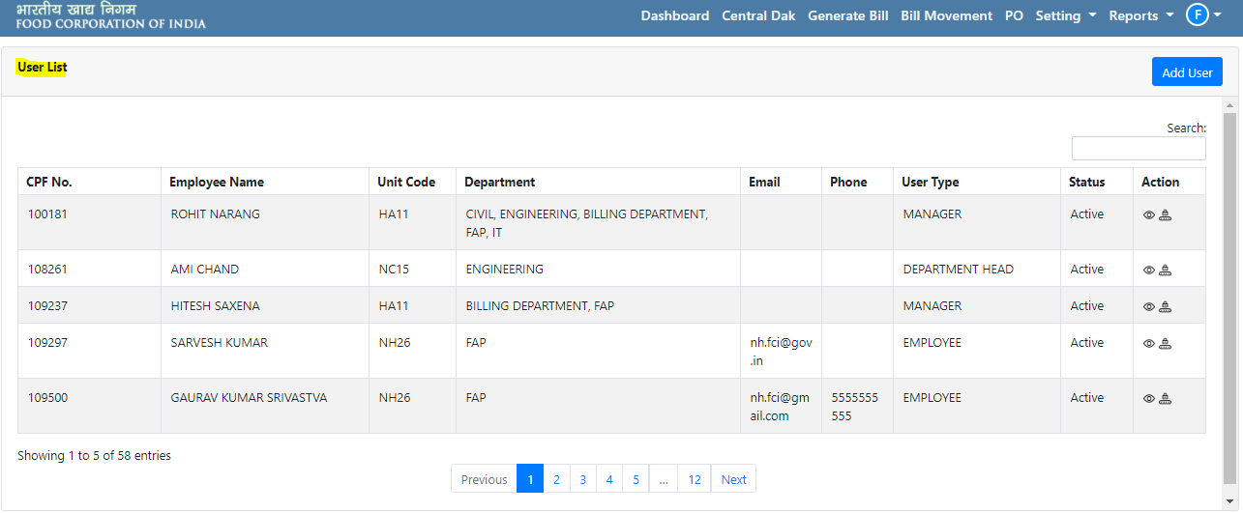

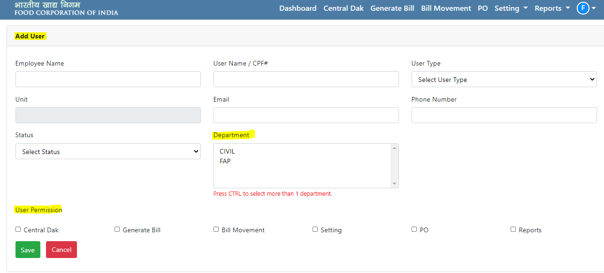
Adding Department:
This option is only available with FAP Support team.
On clicking Department, the added department list will be displayed along with the option to Add Department by providing the following details:
- Department Name
- Description
- Status (Dropdown) (Active, In-Active)
- Save (Button)
- Cancel (Button)
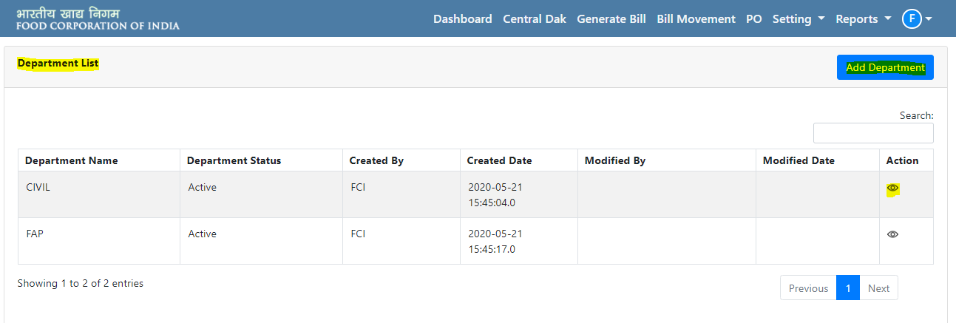
Refer the people images for reference:
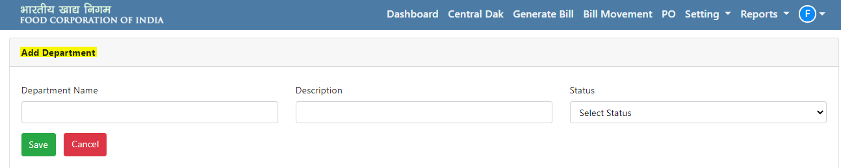
Note:
- Only Admin will be able to create Department
- Departments will be created in a centralised manner and not unit-wise.

- Reports

Step 1: How to view Reports?
The following Reports are available in the Application Bill Tracking System such as:
- Bill Status Report
- Reprint Receipts
- Bill Tracking
- Payment Receipts
- Delay Report
- PO-Wise Bill Report
- Vendor-Wise
- BTS Summary
- BTS Trend Analysis
The admin can search the reports and view its history also against a particular bill.
Refer the below image for better understanding:
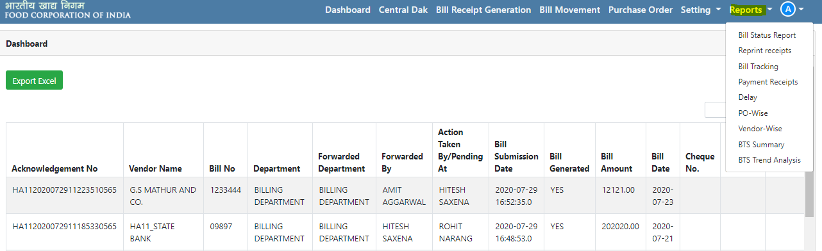
- Bill Status Report:
This report retrieves the list of bills according to following filters (input parameters) such as:
- Unit Code
- Department
- Vendor Name
- Vendor Code
- Employee Name
- CPF Number
- Status and
- Vendor Type
Output is attached for reference

- Delay Report:
This report retrieves the list of bills and their corresponding delays (with Bills, OD and total delay) according to following filters (Input Parameters):
- Unit Code
- From Date
- To Date
- Delay Greater Than
- Bill Amount Greater Than
- Vendor Type
Output is attached for reference
- PO-Wise Bill Report
This report retrieves the details of a bill according to the PO associated with it with PO Number as Input Parameter.
Output is attached for reference

- Supplier Wise Bill Report:
This report retrieves the list of bills and overall bills for a Vendor with Vendor Code and Financial Year as input parameters.

Output is attached for reference

- BTS Summary Report:
This report generates the summary of bills categorized on status filtered with Date Range, Unit Code and Department as input parameters.

Output is attached for reference

- BTS Trend Analysis:
This report generates the number of bills delayed by 15 days for each department with any reference date as input parameter.
Output is attached for reference

Note: The user will be able to download the reports in PDF (.pdf) and Excel (.xls) formats.

- Re-Print Receipts:
The users will be able to take print of the bill under this section by searching the bill through acknowledgement number. On clicking the Print Bill Button, the bill receipt corresponding to respective acknowledgement number will be displayed and the user can take the print of the same. There will be option for users to either Save or Cancel the print.
Output is attached for reference

- Bill Tracking Report:
The users will be able to Search the bill and can also take print of the bill under this section. After providing the acknowledgement number and clicking on Search Button, the bill tracking report corresponding to the acknowledgement number will be generated in which vendor details and bill details such as Vendor Name, Address, PO Number, Bill No., Bill Date, Receipt Number, Payment Details, etc. will be displayed.
On clicking the Print Bill Button, the bill receipt corresponding to respective acknowledgement number will be displayed and the user can take the print. There will be option for users to either Save or Cancel the print.
Output is attached for reference

- Bill Watch System:
The users will be able to Search the bill and can also take print of the bill under this section. After providing the acknowledgement number and clicking on Search Button, the bill status corresponding to the acknowledgement number will be generated in which the bill status will be displayed.
Output is attached for reference

- Vendor Login

Step 1: Where and How users can Login?
FCI’s Admin and other users will be able to Login through following URL:
http://fcilekha.in:7778/billtracker/ on clicking the below screen will appear:

On clicking the Login Button, users will be redirected to the Login Page. Users will also be able to track the bill status like Pending, Rejected, Approved and In-Process by entering the acknowledgement number.
Acknowledgement Number: It is a system generated number consisting of Unit Code and Time Stamp.

Step 2: What processes and information a user can access?
After successful login, the user will be redirected to the Application Bill Tracking System’s Dashboard to access different processes. Vendors have been given the access of only Bill Submission section and the Bill Submitted page will be there Dashboard.
The details of the bills previously submitted by the vendor will be displayed here.
Search: The user will be able to search the details by providing the Search Keyword in the search box.
Export Excel: On clicking, the displayed data on the Dashboard will be downloaded in an MS Excel.
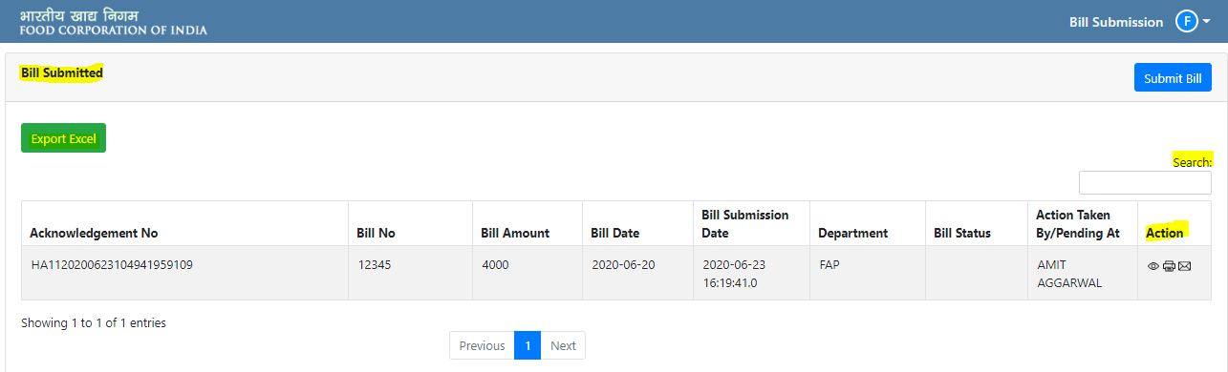
Refer the below image for reference:

Step 3: How to submit a new Bill?
On clicking the Submit Bill Button, a new page will open and the vendors will be required to provide the relevant details such as:
- Department
- Bill No.
- Bill Amount
- Bill Date
- Remarks
- Phone
- Email Address
- Vendor Site
Following buttons will be available to the users:
Generate Acknowledgement No.:- On clicking, a unique Acknowledgement No. will be generated. On successful generation a notification will be displayed on the page.
Attachment: The users will be able to attach multiple files by clicking on this button. (Max. file size of total attachment as 5 MB is allowed, and an error message will be displayed)
Download Attachment: The attached files can be downloaded through this button.
Cancel: On clicking, the Central DAK page will be closed.
Refer the below image:
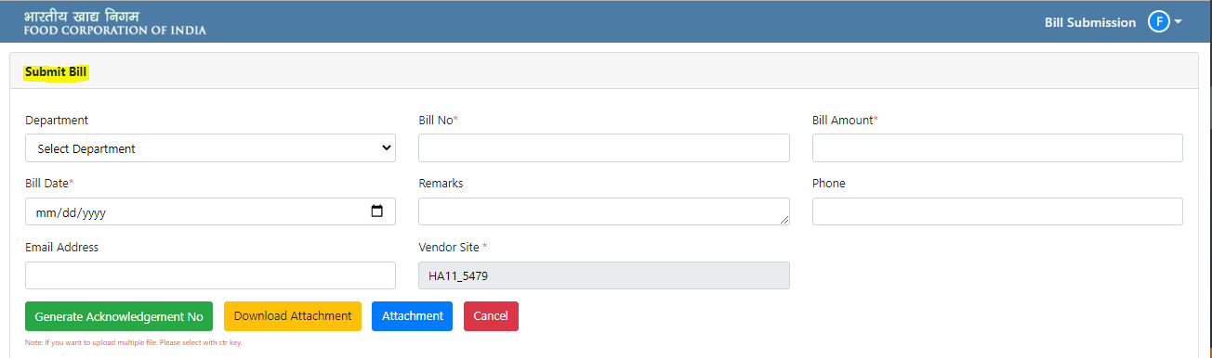
- Payment Status

Step 1: How users can check the payment status?
Users will be able to track the bill status like Pending, Rejected, Approved and In-Process by entering the acknowledgement number.
Acknowledgement Number: It is a system generated number consisting of Unit Code and Time Stamp.
See the below images for better understanding:

Clarification Required against Bill:
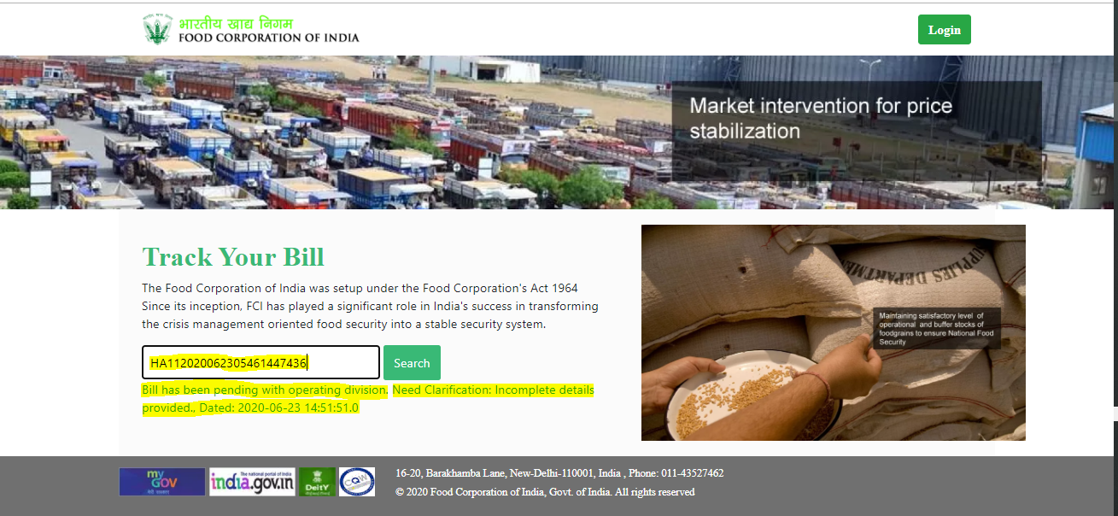

Central DAK created but Bill not Generated:
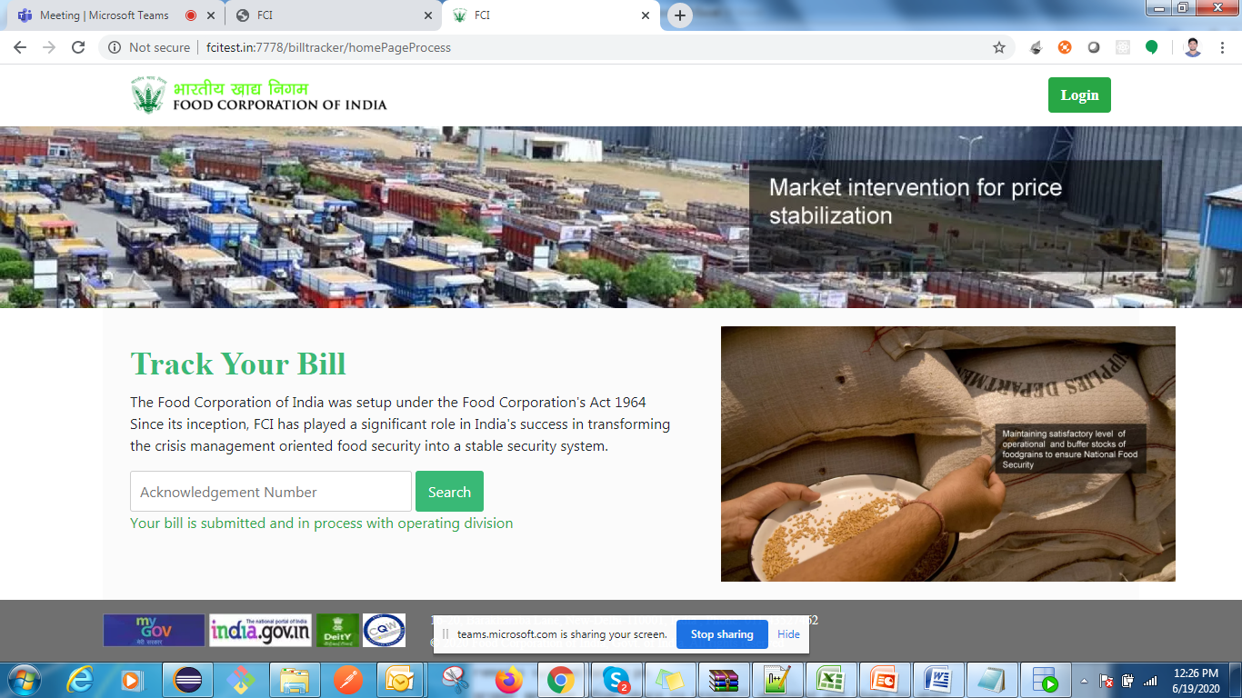

Bill Paid:
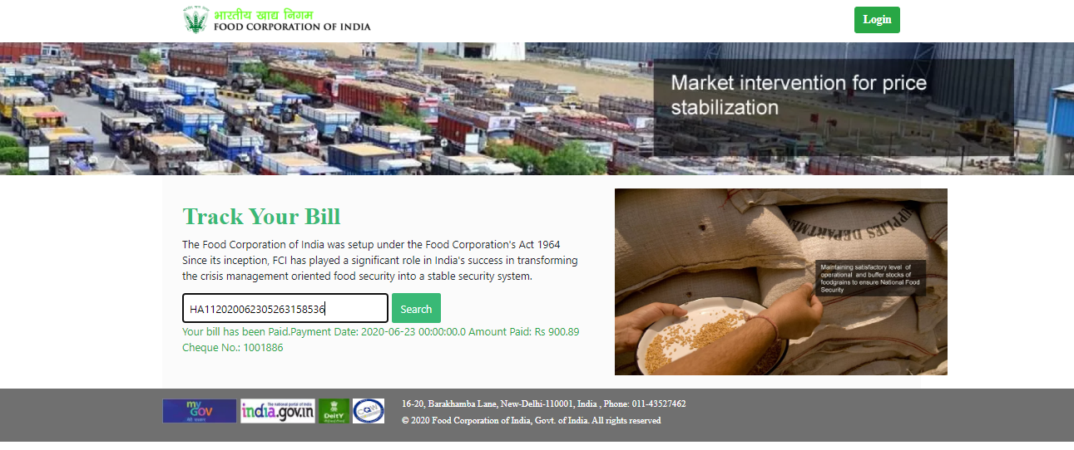

Bill Rejected:
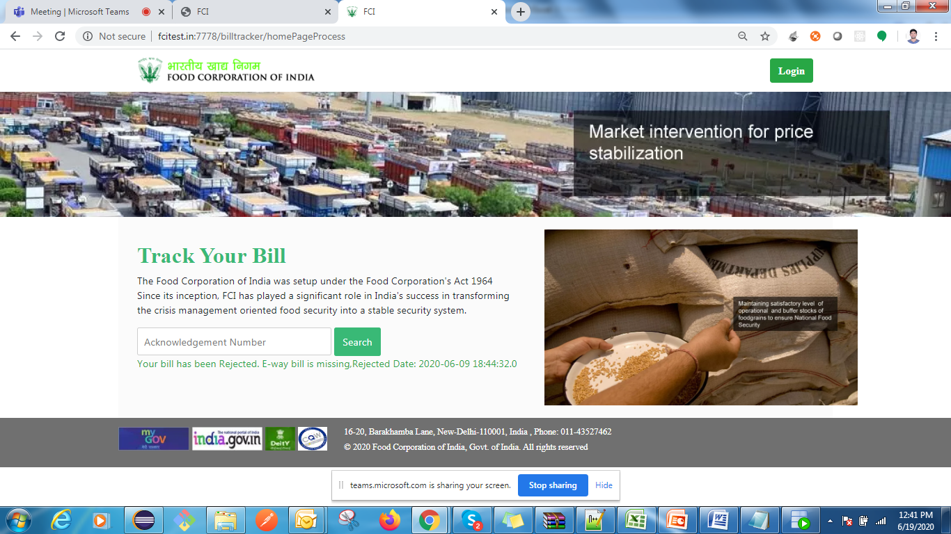

Bill Assigned (InProcess):
